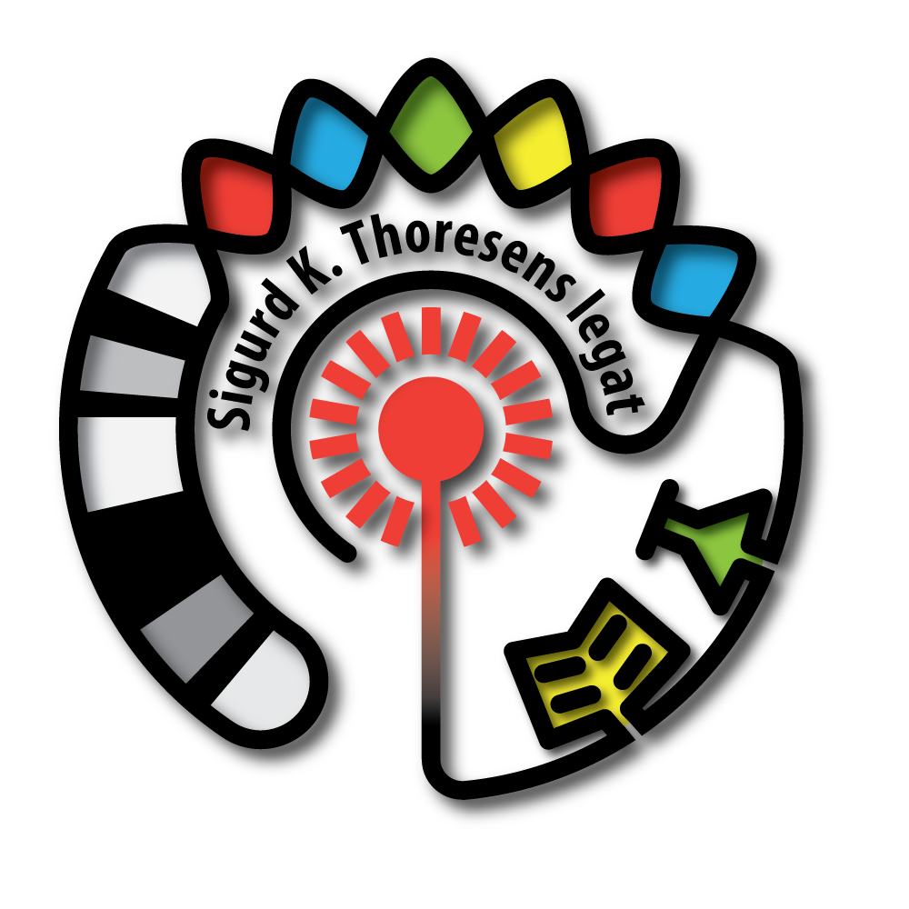
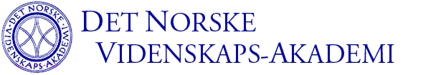



Symposium

“Gene diversity in historical Norway and
its present day applications”

Oslo, November, 2011

organized by the Sig. K. Thoresen Foundation and
The Norwegian Academy of Science and Letters
Street address: Drammensveien 78, Oslo

Programme

Wednesday 2. November

08:30 Stephen H. Friend
Sage Bionetwork, Seattle, USA
Future of genetics in medicine

09:30 Update on Norwegian high profile genetics studies:

09:30-09:55 Ole A. Andreassen,
Oslo University Hospital & Institute of Clinical Medicine,
University of Oslo, Oslo, Norway
New gene discoveries in bipolar disorder and schizophrenia

09:55-10:20 Tom Hemming Karlsen
Oslo University Hospital, Oslo, Norway
Primary sclerosing cholangitis

10:20-10:45 Kristian Hveem
NTNU, Trondheim, Norway
Population based genetics – recent findings and future perspectives.
The HUNT study.

10:45-11:00 Coffee break

11:00-11:25 Camilla Stoltenberg
Norwegian Institute of Public Health, Oslo, Norway
TBA

11:25-11:50 Vidar M. Steen
Haukeland University Hospital, University of Bergen, Bergen, Norway
Norwegian Cognitive NeuroGenetics (NCNG): GWAS on cognition and brain
imaging phenotypes

11:50-12:15 Inger-Lise Mero
Oslo University Hospital, Oslo, Norway
Multiple sclerosis

12:15 Lunch

13:00 Agnar Helgason
deCODE Genetics, Reykjavík, Iceland.
Icelandic population genetics

14:00-15:30 Paneldebatt, debatt med salen
Norske genetiske studier - kan vi benytte DNA-sekvensen for slike formål?
Etiske og lovregulerende aspekter. Rettet mot myndigheter og presse.

15:30-15:40 Eivind Hovig
Oslo University Hospital, The Norwegian Radiumhospital, Oslo, Norway
NorGen – Kort presentasjon av initiativ for å karakterisere den historisk norske genetiske variasjonen

